Ref. No: Date: 04/09/2023.

Notice Regarding 2nd Semester Programme Practical exam
It is hereby notify to all students of 2nd semester programme that practical exam on CHEMGP - 2 will be held on 18/9/2023 as stated below. All students must come just 15 mininutes before from the commencement time of exam at departmental practical room with their own admit card, Lab-coat, Practical Notebook, spatula, dropper etc. No excuse will be entertained. If anyone forgot his/her class roll no please contact to department directly or follow what’sapp group.
Group A: class Roll No: 93 to 2387 (10:30 am to 12:30 pm)
Group B: Class Roll No: 2581 to 3196 & any candidate (4th sem) having supply in 2nd sem practical (1:15 pm to 3:15 pm)
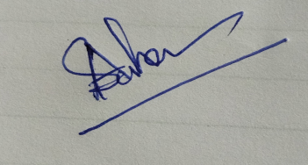
HOD
Department of Chemistry

